Page 1 of 10

E120721: Sociolinguistics

FINAL EXAMINATION

TUESDAY , FEBRUARY 07,2006

Pages 1 – 10

Student’s Full Name
In Arabic : _____________________________
In English : ____________________________
Student’s ID ( Registration number) : -

Tutors’s Name ( in Arabic ) :

EXAM QUESTIONS, GRADES AND TIME ALLOCATION FOR EACH QUESTION:

QUESTION | MINUTES | TOTAL  POINTS | POINTS  EARNED*
First question | 30 | 10
Second question | 45 | 15
Third question | 45 | 15
Fourth question | 45 | 15

Total number of questions you must answer: 3 ( question 1 + any other 2 questions)

- To be filled out by tutor

E120721 Final Exam, 1^{st.} semester, 2006,page 2 of 10

E120721 Final Examination Paper (FEP)
Sociolinguistics

E120721 Final Examination Paper
Time Allowed : 2¼ hours

There are Four questions in this paper : you are required to answer the First question and any other two questions.

You are expected to divide your time as follows:
- 15 minutes for reading through the whole paper and making the appropriate selection of questions . Please remember that your choice of questions must include question number 1 .

- 90 minutes divided equally between the answers of any two of questions 2,3, and 4 .

- 30 minutes for the answer to the first question.

This examination carries 40 marks allocated as follows:
- Questions 2, 3, and 4 : 15 marks each
- Question number 1 : 10 marks

You can answer the questions in any order . You should write only in the space provided after each question . Cross out any rough notes you make which you do not wish to be considered

At the end of the examination

Check that you have written your personal identifier and examination number .
Failure to do so will mean that your work cannot be identified .

E120721 Final Exam, 1^{st.} semester, 2006,page 3 of 10

Question 1 ( 10 marks) ( 30 minutes)

Define and illustrate five of the following concepts:

linguistic repertoire

codeswitching

polyglossia

vernacular

regional and dialect

gender – preferential features
- apparent – time change

E120721 Final Exam, 1^{st.} semester, 2006,page 4 of 10

E120721 Final Exam, 1^{st.} semester, 2006,page 5 of 10

Question 2 ( 15 marks) ( 45 minutes)

What do figures ( 6.3) and (6.4) below tell us about language variation across different areas and social groups . Please notice that groups ore arranged in descending order.

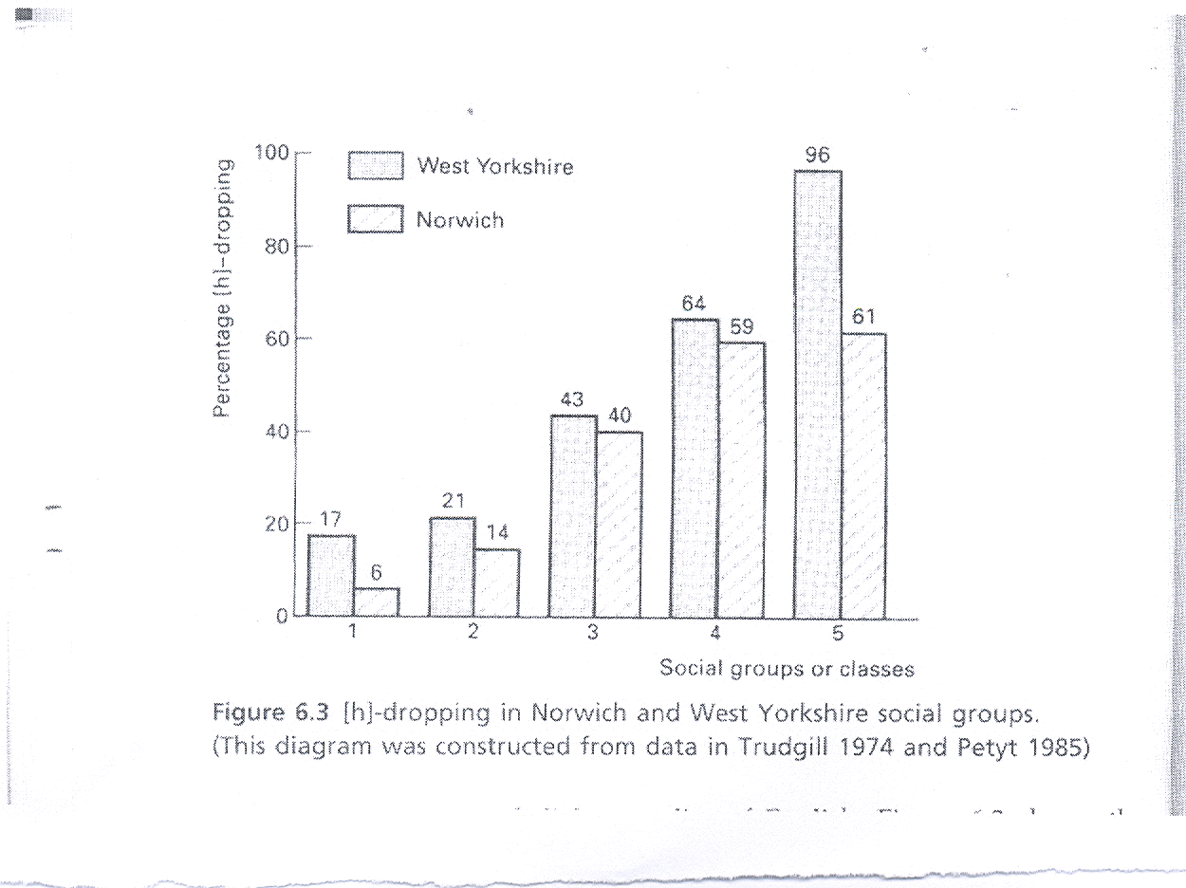

E120721 Final Exam, 1^{st.} semester, 2006,page 6 of 10

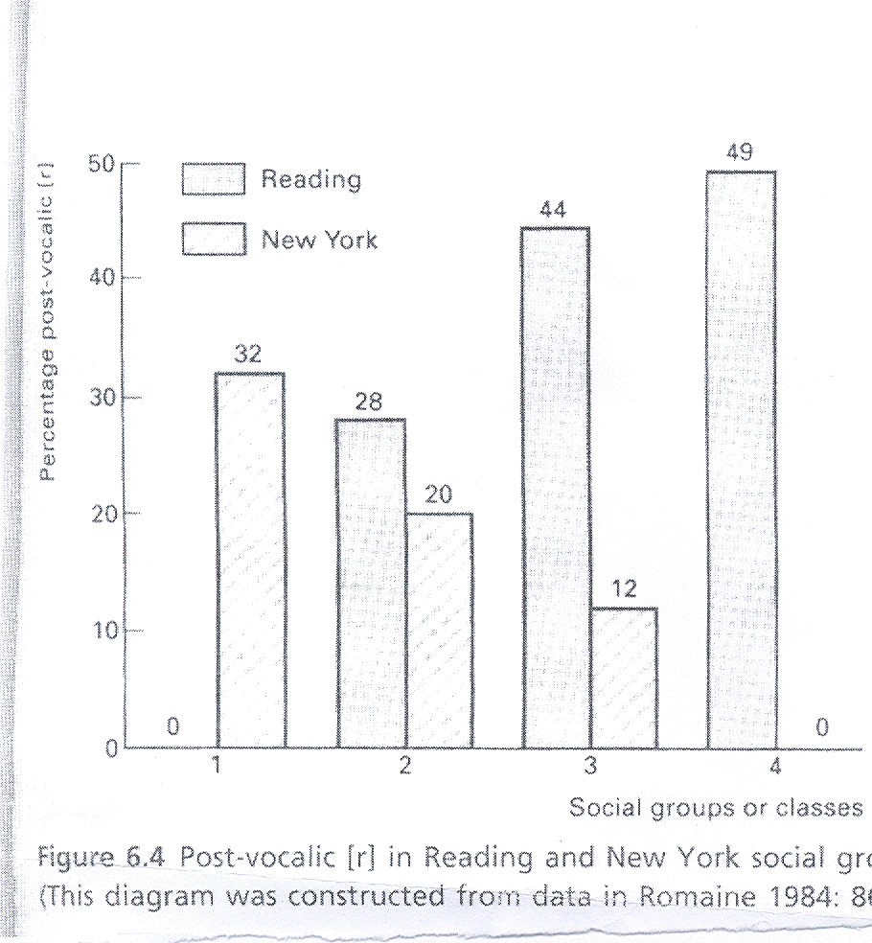

E120721 Final Exam, 1^{st.} semester, 2006,page 7 of 10

Question 3 ( 15 marks) ( 45 minutes)

Language change is influenced by social status, gender , and interaction . Discuss and illustrate two of these factors .

E120721 Final Exam, 1^{st.} semester, 2006,page 8 of 10

E120721 Final Exam, 1^{st.} semester, 2006,page 9 of 10

Question 4 ( 15 marks) ( 45 minutes)

How does the new sociolinguistic approach make “ sense of what had appeared to be chaotic and unsystematic linguistic variability” in urban communities? Please make sure you give enough examples and supporting evidence.

E120721 Final Exam, 1^{st.} semester, 2006,page 10 of 10

